Determining the Better Equipment and Data Analysis of the Corresponding Equipment

* Herman Li
* 20/04/2022

Using 2 optical mirrors to create a path for a green 532nm laser, a portion of light is deflected and aimed at a photodiode with gain 0.583 to detect the excitation pulse (measure in volts) with triggering voltage 0.206V. This triggering voltage is above a smaller pulse produced by the laser periodically. The light that passes through hits a Dichroic mirror and is either deflected to the right or passes through the Dichroic mirror. The portion of light that passes through the Dichroic mirror goes through a Neutral Density (ND) filter and is detected by a Photomultiplier with gain 0.474 which represents the Green return. The portion of light that is deflected to the right hits a focal lens () and finally comes into contact with our distilled water sample which is stored inside a cuvette within a temperature-controlled Q-pod. After the interaction, there will be a Raman signal returned which passes directly through the Dichroic mirror, long pass filter and finally a 50-50 beam splitting cube where there will be 2 ND filters and 2 Photomultipliers with gain 0.580 and 0.584 which detect Raman returns at 660nm and 640nm respectively. All 4 channels (3 PMTs and 1 PD) are linked to a Tektronix DPO4104B Oscilloscope.

This can be seen visually below:

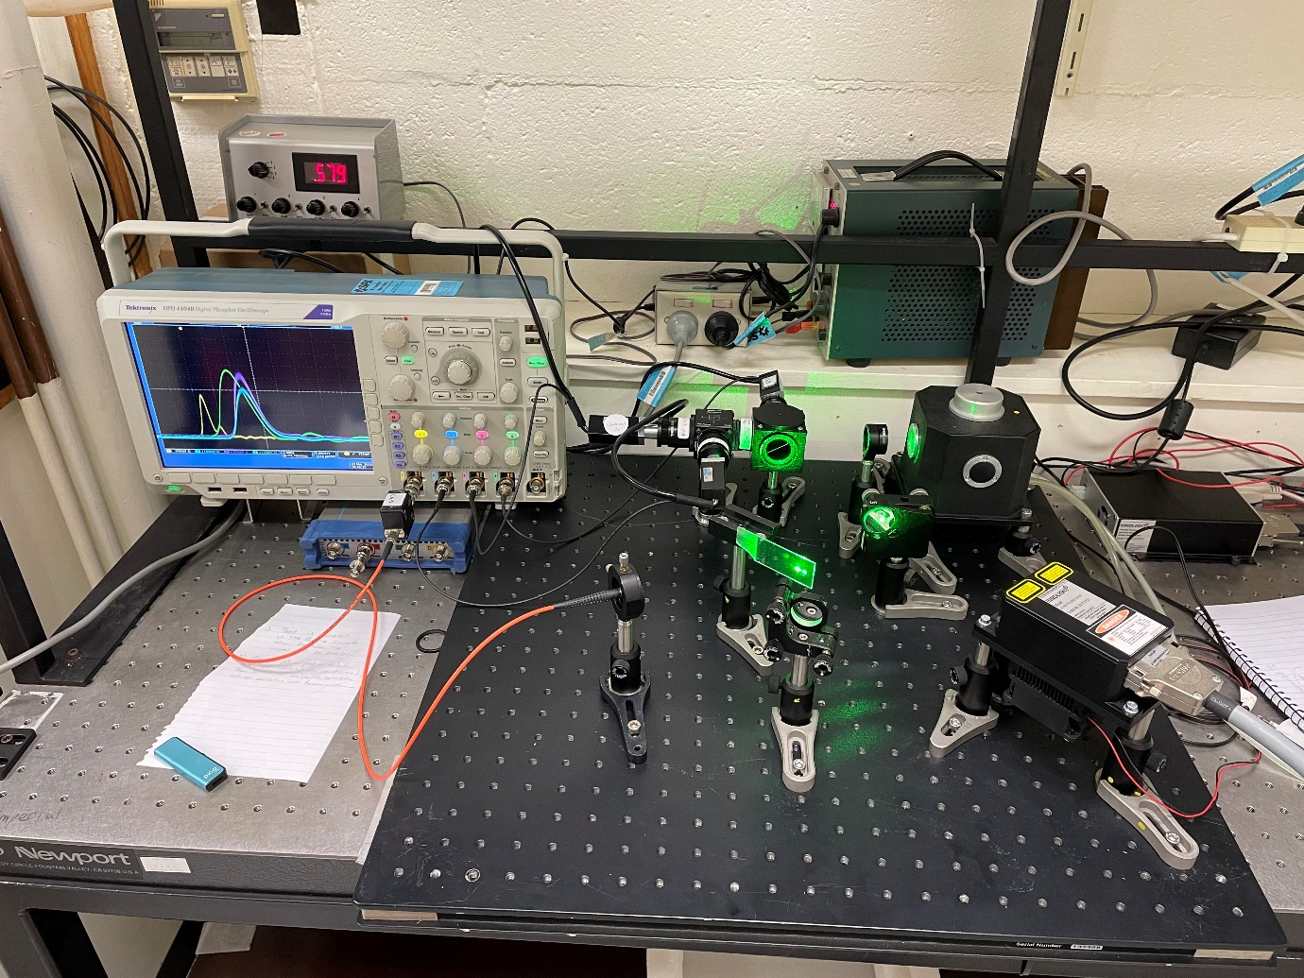

Cuvette inside Temp. Controlled Q-pod

Focal lens

Oscilloscope

Photodiode

Optical Mirrors

PMT 2

PMT 3

50-50 BSC

LP Filter

Dichroic Mirror

PMT 1

Laser

Laser

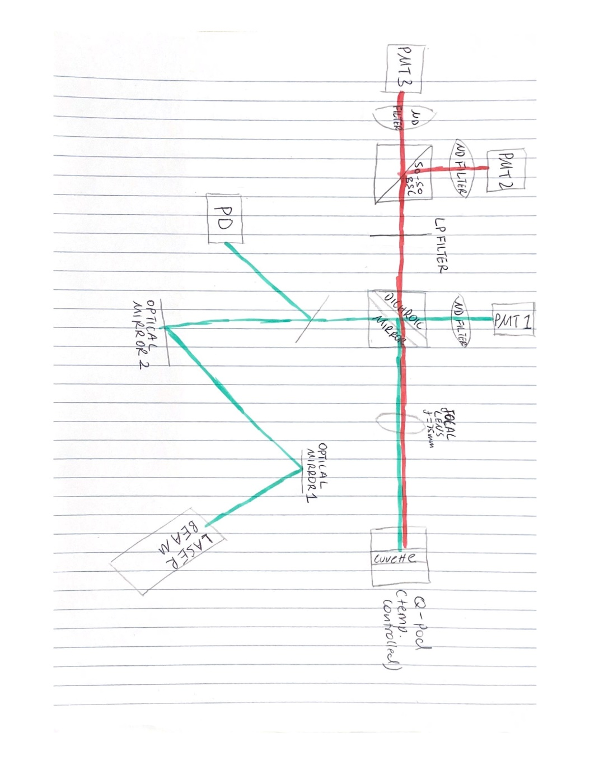This can also be represented using a Schematic Diagram as shown below, it is equivalent to the image of the set up above:

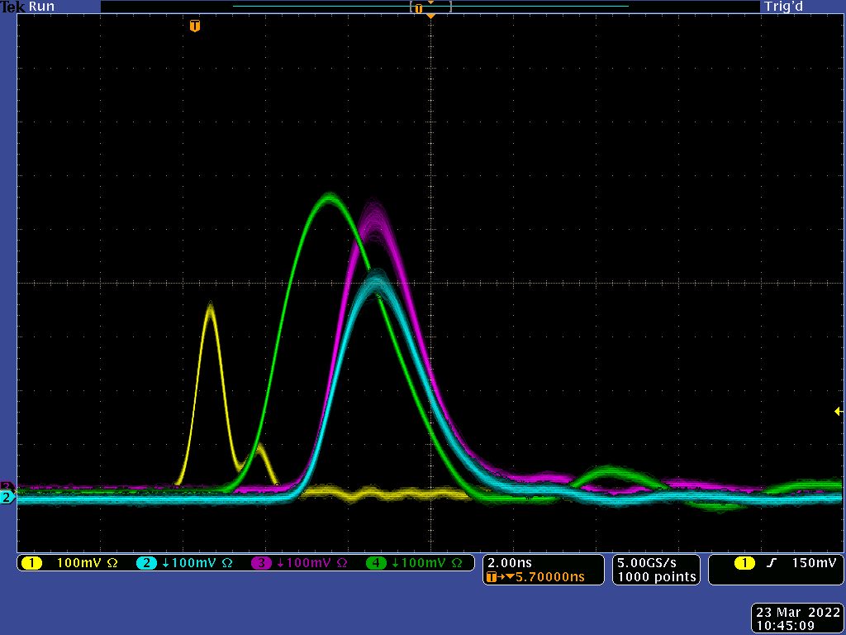With this set up, we have an oscilloscope output as shown below:

The data taken was 512 individual detections by the oscilloscope, the oscilloscope samples at a rate of 5 giga-samples/second so each file contains 1000 datapoints. It is more meaningful to discuss the all this data as an average, so tabulated below is the average peak value (in V), average time of peak occurrence i.e. when the maximum peak occurs (in nanoseconds) and average FWHM value i.e. pulse duration (in nanoseconds) along with their corresponding standard deviations across the 4 channels.

**Average Peak Value (V):**

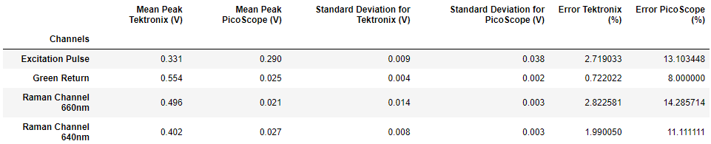

**Average Time of Peak Occurrence (ns):**

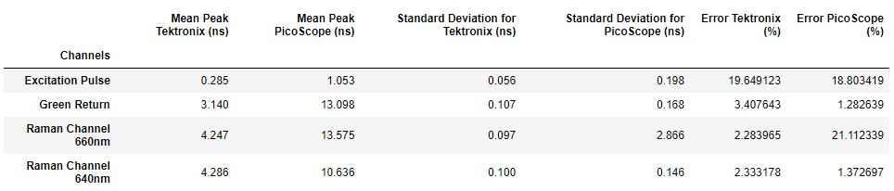**Average FWHM (ns):**

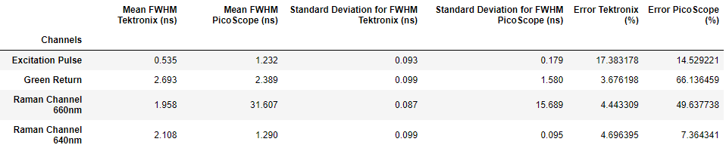

The PicoScope data was collect in a similar way, the set up was the same but instead of connecting to the Oscilloscope, the channels were connected to a PicoScope. Comparing across all 3 tables, it is clear to see that the error (as a form of percentage) of the PicoScope is much higher than that of the Oscilloscope. The error of the PicoScope ranged up to 66%.

A driving factor for the large error percentage for the PicoScope will be due to its sampling capabilities. According to their [datasheet](https://www.farnell.com/datasheets/2162834.pdf), the sampling rate of the PicoScope is directly correlated to the number of active channels.

* With 1 active channel, the sampling rate is 5GS/s
* With 2 active channels, the sampling rate is 2.5GS/s
* With all 4 active channels, the sampling rate is 1.25GS/s

Since all 4 channels are required for detection, the sampling rate is effectively 1.25GS/s and not 5GS/s as desired.

Contrasting this, the Oscilloscope has a sampling rate of 5GS/s independent of the number of active channels (reference to Oscilloscope [datasheet](https://au.mouser.com/datasheet/2/403/MSO4000_DPO4000_Mixed_Signal_Oscilloscope_Datashee-2308128.pdf)), demonstrating the reason for a much high accuracy.

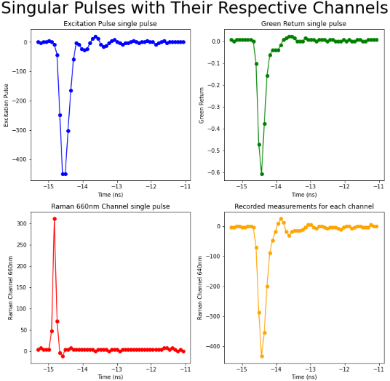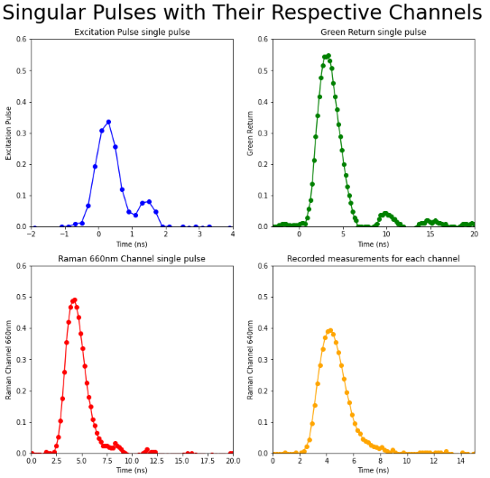This can be further portrayed by a scatterplot comparing the 2 devices:

**Generated by: Oscilloscope data** **Generated by: PicoScope data**

The under-sampling issue is more evident than ever, there are 12 points which make up the shape for the excitation pulse when plotting with the Oscilloscope data. Compare this to 7 points which make up the excitation pulse when plotting with PicoScope data. It is also important to see that while the curve generated by the oscilloscope may not be perfect, it is easy to pinpoint quite close to the true peak of the curve. This is not the case with the PicoScope data, where the peak seemed to be determined by 2 points (instead of 1), easily demonstrating that the peak has been missed in this particular sample.

Perhaps worst is the PicoScope sampling of the Raman Return 660nm, where the curve is plotted by only 3 points­­. This equipment is clearly unfit for the purpose of the experiment.

Now to address an important issue – Ringing. It is clear to see that for the Excitation Pulse and Green Return that ringing is occurring, for the 2 Raman Return channels it is not as obvious.

For the Excitation Pulse, there is 1 ring which occurs for roughly 1 ns and is about 0.1V which is about 28% of the pulse maximum.

For the Green Return, there are about 2-3 rings which are 5 ns apart and decays very rapidly in amplitude with the largest ringing amplitude at about 0.05V and being only 10% of the pulse maximum.

It is possible to argue that there is no ringing for the Raman returns, however, if there is, it is just very slight. For the Raman Return 660nm, there is a small tail to the right which lasts about 2 ns at about 0.02V and being 4% of the pulse maximum.

There is no ringing for the Raman return 640nm. However, there is a small tail at the right of the graph, it doesn’t deserve to be characterized as ringing, but it is making the graph look a little skewed, perhaps something different is happening there.

The significance/insignificance of the ringing requires more research.

The next step would be to observe correlation. Begin by plotting Excitation Pulse vs Excitation Pulse to check whether the dataset makes sense, then plot the Excitation Pulse against all other returns. Here, it is expected that all graphs should return some form of linear relationship, i.e. the stronger the excitation pulse the stronger the return signal should be on other Channels. The resulting graph is shown below:

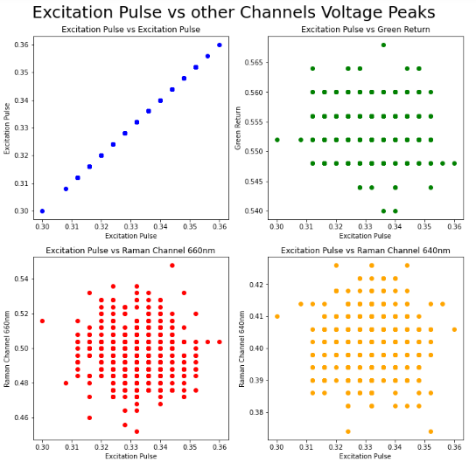

Unfortunately, the expected outcome is not what is being observed. This is because the laser being used has 2 power options, on or off. That is a problem, even though there are changes in peak heights as shown in Excitation Pulse vs Excitation Pulse plot, there is no way of tracking which point on the other graphs corresponds with the higher or lower excitation pulse. However, if we had many power options, then we can slowly step up the power and draw a better conclusion. It is theorized that since not all 512 points are shown in any of the plots, there could be many points along a linear line and that the cloudy distribution is the noise of the system. Essentially, there is not much to be learned about the system here.

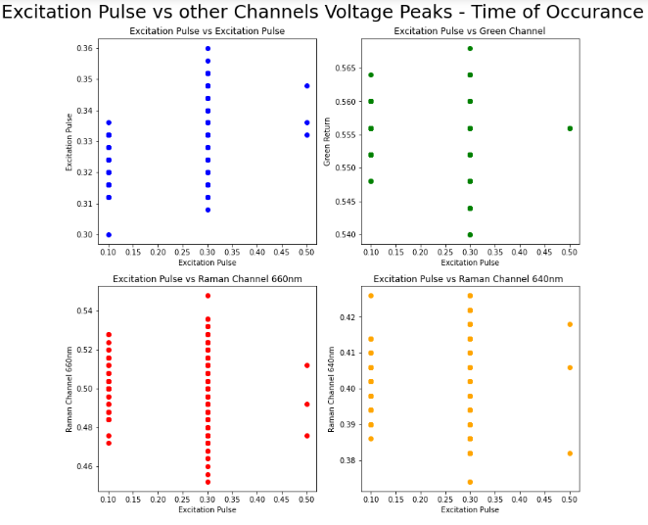Doing the exact same analysis but on the time that the peak occurs, the resulting graph is shown below:

Although there is not much being shown here, it is important to note that we are actually able to see very clearly the sampling rate of 5GS/s of the Oscilloscope in action. It samples a point every 0.2 nanoseconds, this is consistent with the scatterplot above where 5 points were identified every nanosecond of measurement.

Finally, it is important to check whether the data obtained initially was reasonable, so it is good to compare the averages calculated by Python with an average calculated automatically by the Oscilloscope. A comparison of the 2 has been tabulated below, one of the maximum peak heights and one of the FWHM.

**Mean Max peak heights**

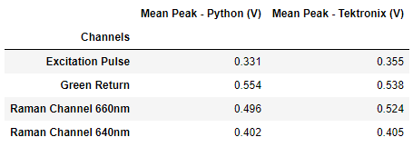

**Mean FWHM**

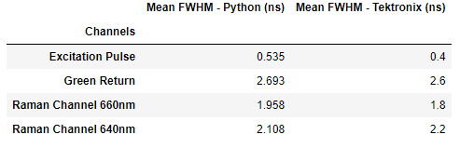

Although there is a difference in the 2 averaged values, it is a very small discrepancy. Since we have taken the mean of 512 individual dataset, there is a calculated standard deviation, the discrepancy between the calculated mean values is so small that the mean values calculated by Tektronix are within that standard deviation. This applies for both the mean max peak and FWHM. The gives confidence to both the calculated values and the mean calculated by the oscilloscope.

In conclusion, it has been proven that the PicoScope is not fit for the rigorous measurements needed for this project. Therefore, the sampling rate and accuracy of the Tektronix Oscilloscope is preferred. Although the ringing has a relatively low amplitude and dies away quite quickly, it is an issue which has been identified but not resolved, more research is required to determine the significance of the ringing observed. More research is also required to discover any correlation between the excitation pulse and various other returns. However, we end with a positive note and that is the reassurance of high-resolution averages of important values.